Ques - 2

Analyzing Ethernet frames and MAC using Wireshark

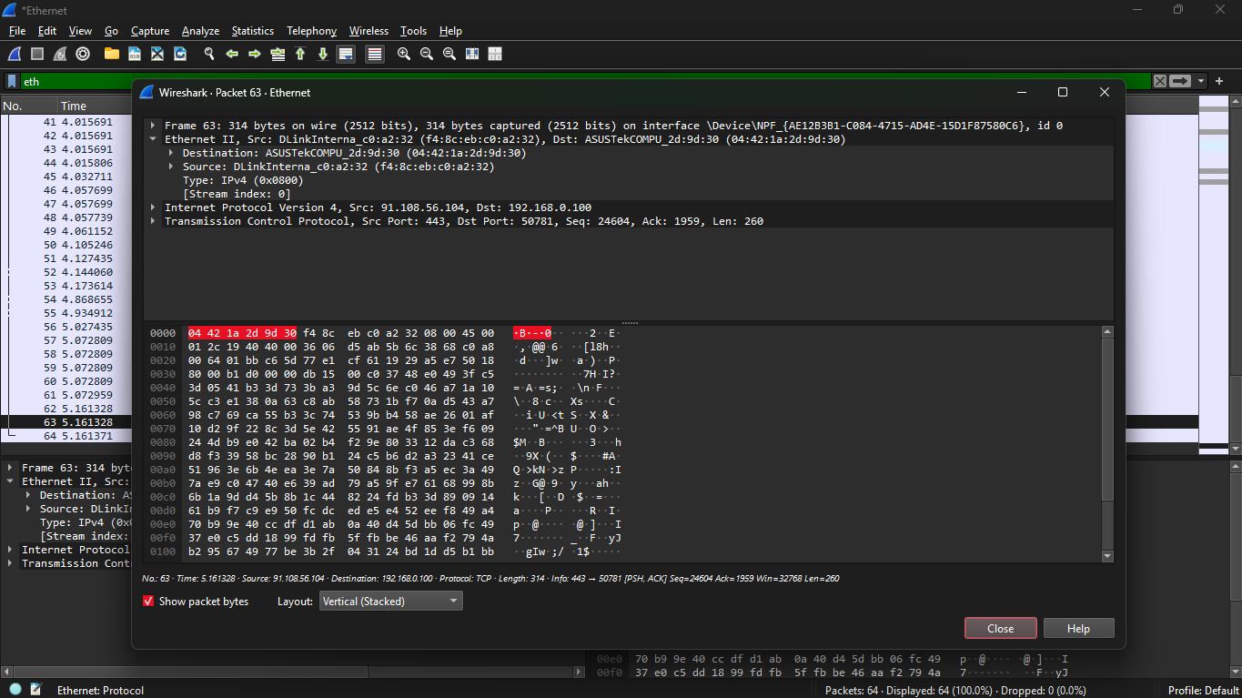

Destination MAC Address: 04:42:1a:2d:9d:30

This is the MAC address of the receiving device.

It helps the switch forward the frame to the correct machine.

Source MAC Address: f4:8c:eb:c0:a2:32

This is the MAC address of the sending device.

The switch learns this address to update its MAC table.

EtherType: 0x0800 (IPv4)

Indicates that the payload contains an IPv4 packet

Payload: Contains IP and TCP data

The encapsulated TCP packet carries higher-layer information, such as source and destination ports.